**Lab Task 1.**

1. Create the following GUI using manual method (No drag-and-drop). The “ClientDB” is an image, which can be set to a JLabel using its setIcon method (See example in Fig 14.6). The program may follow any layout (e.g. flowlayout), this means the placement of components need not be in the exact order as shown.

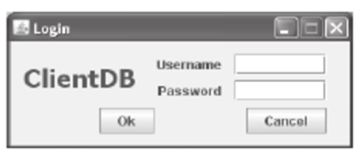

1. Modify the above program, so that the program first shows a couple of dialog boxes to input user name and password. These inputs should be shown in the appropriate text boxes, when the user is done with the input. (Hint: use JOptionPane.showInputDialog + see example in Fig. 14.2).

**Lab Task 2.**

Create the following GUIs step-by-step using the WindowBuilder drag-and-drop method. Explore the properties of different components added in GUIs using the attributes panel in WindowBuilder. Also, open the code editor during GUI design and note down the changes made in each step so that you understand the underlying code while designing the GUIs.

